Stack

1. Stack is an ordered list in which, insertion and deletion can be performed only at one end that is called **top**.
2. Stack is a recursive data structure having pointer to its top element.
3. Stacks are sometimes called as Last-In-First-Out (LIFO) lists i.e. the element which is inserted first in the stack, will be deleted last from the stack.

Applications of Stack

1. Recursion
2. Expression evaluations and conversions
3. Parsing
4. Browsers
5. Editors
6. Tree Traversals

Operations on Stack

There are various operations which can be performed on stack.

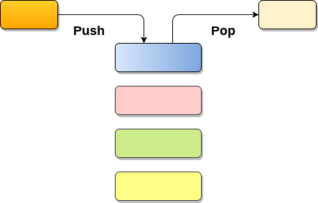

**1. Push :** Adding an element onto the stack

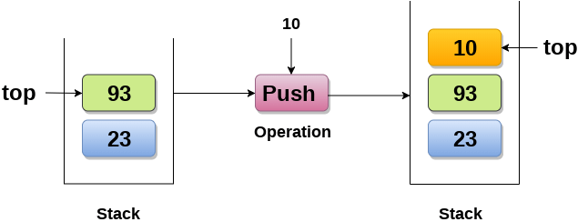

**2. Pop :** Removing an element from the stack

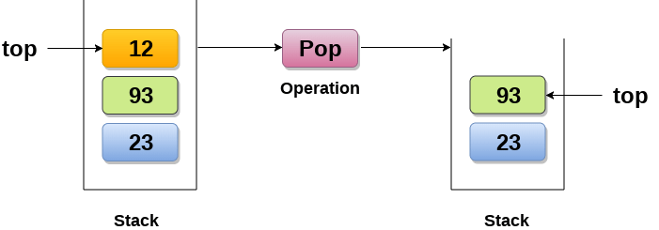

**3. Peek :** Look all the elements of stack without removing them.

How the stack grows?

**Scenario 1 : Stack is empty**

The stack is called empty if it doesn't contain any element inside it. At this stage, the value of variable top is -1.

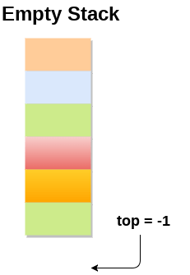

**Scenario 2 : Stack is not empty**

Value of top will get increased by 1 every time when we add any element to the stack. In the following stack, After adding first element, top = 2.

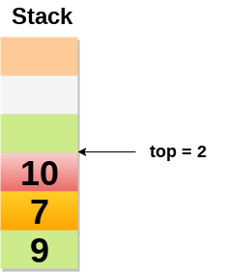

**Scenario 3 : Deletion of an element**

Value of top will get decreased by 1 whenever an element is deleted from the stack.

In the following stack, after deleting 10 from the stack, top = 1.

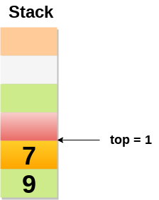

Top and its value :

|  |  |
| --- | --- |
| **Top position** | **Status of stack** |
| -1 | Empty |
| 0 | Only one element in the stack |
| N-1 | Stack is full |
| N | Overflow |